<<COURT_NAME>>

|  |  |
| --- | --- |
| <<PROVIDER_SUITNAME>>,  a/a/o <<INJUREDPARTY_NAME>>  Plaintiff,  vs.  <<INSURANCECOMPANY_SUITNAME>>  Defendant  _______________________________________/ | Case No. <<INDEXORAAA_NUMBER>> |

**PLAINTIFF’S MOTION FOR EXTENSION OF TIME**

**TO FILE RESPONSES TO DEFENDANT’S DISCOVERY REQUESTS**

Plaintiff, <<PROVIDER_SUITNAME>>, by and through the undersigned counsel, hereby files its Motion for Extension of Time to File Responses to Defendant’s Discovery Requests, and in support thereof states as follows:

1. Plaintiff files this Motion for Extension of Time and requests an additional twenty (20) days to file responses to Defendant’s Discovery Requests, up to and including <<20_DAYS_FROM_TODAY>>.

2. Plaintiff certifies that this motion is made in good faith and not for the purposes of delay.

3. Defendant will not be prejudiced by a short extension of time.

**CERTIFICATE OF SERVICE**

I HEREBY CERTIFY that on February 19, 2022, a true and correct copy of the foregoing was filed and served on the Defendant through Florida Courts E-Filing Portal.

**Florida Insurance Law Group, LLC**

8724 Sunset Drive, #260, Miami, FL 33173

Tel. (305) 906-4262

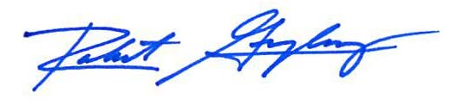

Robert F. Gonzalez, Esq.

Fla. Bar No. 68865

Pleadings@flinslaw.com